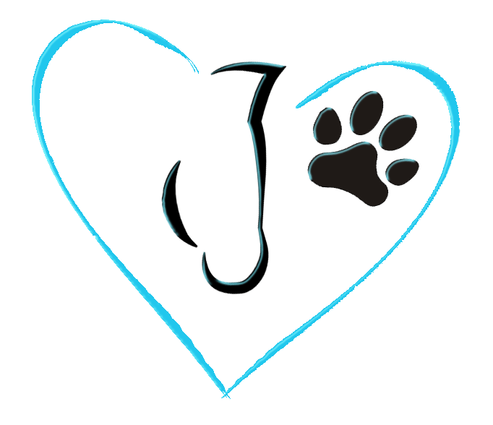
Returns & Refunds Policy

Received the Wrong Size?

Clients have 30 days from purchase to contact us about any mistakes made to their original order.
Product must be new and un opened.

We will be happy to make sure you receive exactly what you ordered.

Exchanges

Ordered the wrong size or has your hay bale changed size?

Clients have 30 days to make any exchanges from date of purchase on any new unused products. Customer to pay all shipping fees.

Returns

If you need to return unused product, please contact us and we will respond with instructions for how to return items from your order and provide a Return Mail Slip. Customer to pay all shipping fees.

Disclaimer

The owners and/or employees of Knaughty Nets & Pets are not responsible for any injury or damage of any kind with the use of products from Knaughty Nets & Pets.

Shipping

We can ship virtually anywhere in the world, although there may be restrictions.

Contact Us to arrange shipping of Steel Feeders.

If your country is not shown or you have a large order, please Contact Us to discuss alternate shipping arrangements.

