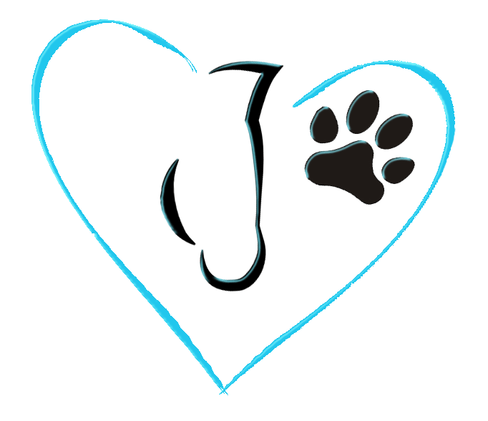
Knaughty Nets & Pets

Home of the Happy, Healthy Horse & Hound
DONATION APPLICATION

Knaughty Nets & Pets would like to thank you for your interest in our Donation Program. We love providing products that support our equine and canine athletes in making them happier and healthier!! Please read through the questionnaire and send it back into us, the more information the better!!

Completed forms may be submitted: By Email: knaughtynetsandpets@hotmail.com

By Mail: Knaughty Nets Donations
RR 1 Site 12 Comp 16
Millet, AB, T0C 1Z0

Drop off at shop: 241009 Hwy 814
Millet, AB
780-235-8844
Monday – Friday 9am – 3:30pm

CONTACT INFORMATION:

Name:________________________________________________________________________

Address:_______________________________________________________________________

Phone Number:__________________________________________________________________

Email Address:____________________________________________________________________

Name of Organization:______________________________________________________________

DONATION DETAILS: What type of donation are you requesting? (Check all that apply)

- Product
- Donation (Less than $500)
- Donation (More than $500
- Advertising
- Event
- Team/Club
- Personal
- Other______________________________________________________
PLEASE EXPLAIN WHY YOU WOULD LIKE A DONATION: (Who benefits, what is done with the proceeds, how many events/activities do you/your club/team participate in throughout the year?)
_______________________________________________________________________________________________________________________________________________________________________________________________________________________________________________________________________________________________________________________________________________________________________________________________________________________________________________________________________________________________________________________________________________________________________________________________________________________________________________________________________________________________________________________________________________________________________________________________________________________________________________________________________________

EVENT DETAILS: (If you checked event donation)

Name of event:________________________________________________________________

Event date:____________________________________________________________________

Event location:_________________________________________________________________

Event web site:________________________________________________________________

Number of years for event:_______________________________________________________

Is this event for or benefiting a non-profit? Y/N

If so, which one?_______________________________________________________________

Non-profit website:_____________________________________________________________

WHAT IS THE GOAL? (Please be specific)
___________________________________________________________________________________________________________________________________________________________________________________________________________________________________________________________________________________________________________________________________________________________________________________________________________________________________________________________________________________________________________________________________________________________
__________________________________________________________________________________________________________________________________________________________

COMMENTS & ADDITIONAL INFORMATION (Anything you think will help)
___________________________________________________________________________________________________________________________________________________________________________________________________________________________________________________________________________________________________________________________________________________________________________________________________________________________________________________________________________________________________________________________________________________________

We ask that you keep us updated with the events we may be making a donation towards. We appreciate seeing and receiving photos of the recipients of our donations.

_____________________________By signing here, I confirm that Knaughty Nets & Pets are allowed to use this information for any social media and/or advertising on the Knaughty Nets & Pets website and Social Media pages. (We will not share any contact information unless advised.)

Knaughty Nets & Pets reserves the right to change or discontinue this program at any time.

